**1.INTRODUCTION**

**1.1 MOTIVATION**

As the problem of urban traffic congestion spreads, there is a pressing need for introduction of advanced technology to improve the state of art of traffic control. In current situation, the signal remain green even if the vehicles have passed.

Detection and classification of vehicle is essential for effective traffic control, for which, traffic related information needs to be collected and analyzed.

Some other techniques are Magnetic Wireless Sensor detectors[1], Radio Frequency[2], Regression Analysis[3], Motion Vector Technique[4], etc. Standard traffic control system is is Manual Controlling, in which more man-power is required.

**1.2 BASIC DEFINITION**

To create a web application which shows the image instances of vehicles at traffic signal. Then it computes the number of vehicles at each side and shows the signal accordingly.

Firstly, traffic density is measured at signals and accordingly change time delays for traffic lights the side at which the traffic is more. In today’s era, Transportation is very important, because of which traffic is increased, and to reduce this we need better traffic control system, which is able to cope up with traffic situation and change controlling as per the situation. Such an intelligent system will reduce traffic without affecting transportation.

**1.3 PROBLEM STATEMENT**

To develop an application that computes the number of vehicles at each side of the signal and show the signal accordingly. Manually it is not possible to control traffic effectively. Another system is Automatic Controlling, which uses timer for each phase. Electronic sensors are used to detect vehicles and produce signals. Time may get wasted by a green light on empty road. All these limitations are supposed to be eliminated via Image Processing, in which detection of vehicles is done through image instances.

**2.EXISTING SYSTEM**

Manual Controlling: requires extra man power. Moreover, only skilled operators can make judgements, hence, there is very high work load on skilled operators. There are many disadvantages in manual controlling mainly if the operator takes a wrong decision may cause many accidents.

Microcontroller : controls the traffic lights at the zebra crossing or we can say traffic junction, which is not a flexible method, rather, there is fixed on and off timings for yellow, green and red lights.

Automatic Traffic Light: performs its functioning through sensors and timers. Depending on timer values, lights are automatically getting ON and OFF. It will not solve the problem of waiting for a long time if one side has less traffic the timer is set previously may be long. Hence there may be more waiting for the people at that side of traffic junction.

Vehicle Actuated Control: continuously attempt to adjust green light times. One of the major drawback is that it does not take into account the vehicles waiting at the red. A detector is located at a distance ahead of stop line and it sends the controller sensitive to signals. The system will work only if the assumed flow matches the actual traffic flow.

Sensors: Another technique is using sensors where wastage of time by constant on green light on a bare road. Hence, by using Automatic Traffic Light traffic congestion is still an issue.

**3.PROPOSED SYSTEM**

**3.1 METHODOLOGY**

The image instances of vehicles at traffic signal are given to the computer system .Then it computes the number of vehicles at each side and shows the signal accordingly using object detection in python.

This ObjectDetection class provides you function to perform object detection on any image or set of images, using pre-trained models that was trained on the COCO dataset. The models supported are RetinaNet, YOLOv3 and TinyYOLOv3. This means you can detect and recognize 80 different kind of common everyday objects.

**3.2** **ARCHITECTURE OF PROPOSED SYSTEM**

Image instances

Computer System

count of 4th image instance

count of 3rd image instance

count of 2nd image instance

count of 1st image instance

Check the maximum of 4 counts

Show the green signal to the image instance which has highest number of vehicles

Fig 3.1Archiecture of the proposed system.

As shown in Fig 3.1 The image instances of vehicles at traffic signal are given to the computer system .Then it computes the number of vehicles at each side and shows the signal accordingly using object detection in python.

This ObjectDetection class provides you function to perform object detection on any image or set of images, using pre-trained models that was trained on the COCO dataset.The count of each vehicles in each image is counted and represented as count1,count2,count3 and count4 respectively.We find the maximum of this count1,count2,count3 and count4 and Show the green signal to the image instance which has highest number of vehicles

**4. SOFTWARE AND HARDWARE REQUIREMENTS**

### HTML

HTML stands for Hyper Text Markup Language, which is the most widely used language on Web to develop web pages. HTML was created by Berners-Lee in late 1991 but "HTML 2.0" was the first standard HTML specification which was published in 1995. HTML 4.01 was a major version of HTML and it was published in late 1999. Though HTML 4.01 version is widely used but currently we are having HTML-5 version which is an extension to HTML 4.01, and this version was published in 2012.

The <!DOCTYPE> declaration tag is used by the web browser to understand the version of the HTML used in the document. Current version of HTML is 5. There are many other declaration types which can be used in HTML document depending on what version of HTML is being used.

As told earlier, HTML is a markup language and makes use of various tags to format the content. These tags are enclosed within angle braces <Tag Name>. Except few tags, most of the tags have their corresponding closing tags.

An HTML element is defined by a starting tag. If the element contains other content, it ends with a closing tag, where the element name is preceded by a forward slash as shown below with few tags. HTML elements which don't need to be closed, such as <img.../>, <hr /> and <br /> elements. These are known as void elements. HTML documents consists of a tree of these elements and they specify how HTML documents should be built, and what kind of content should be placed in what part of an HTML document.

**CASCADING STYLE SHEET**

Cascading Style Sheets (CSS) describe how documents are presented on screens, in print, or perhaps how they are pronounced. CSS provide easy and effective alternatives to specify various attributes for the HTML tags. Using CSS, you can specify a number of style properties for a given HTML element. Each property has a name and a value, separated by a colon (:). Each property declaration is separated by a semi-colon (;). You can use CSS in three ways in your HTML document.

External Style Sheet, if you need to use your style sheet to various pages, then it’s always recommended to define a common style sheet in a separate file

A cascading style sheet file will have extension as .css and it will be included in HTML files using <link> tag.

Internal Style Sheet, if you want to apply Style Sheet rules to a single document only, then you can include those rules in header section of the HTML document using <style> tag. Rules defined in internal style sheet overrides the rules defined in an external CSS file.

Inline Style Sheet, you can apply style sheet rules directly to any HTML element using style attribute of the relevant tag. This should be done only when you are interested to make a particular change in any HTML element only. Rules defined in-line with the element overrides the rules defined in an external CSS file as well as the rules defined in <style> element.

**JAVA SCRIPT**

A script is a small piece of program that can add interactivity to your website. This script could be written using JavaScript or VBScript. You can write various small functions, called event handlers using any of the scripting language and then you can trigger those functions using HTML attributes. Now-a-days, only JavaScript and associated frameworks are being used by most of the web developers, VBScript is not even supported by various major browsers. you can keep JavaScript code in a separate file and then include it wherever it's needed, or you can define functionality inside HTML document itself. Let's see both the cases one by one with suitable examples.

External JavaScript, if you are going to define a functionality which will be used in various HTML documents then it's better to keep that functionality in a separate JavaScript file and then include that file in your HTML documents. A JavaScript file will have extension as .js and it will be included in HTML files using <script> tag.

Internal JavaScript, you can write your script code directly into your HTML document. Usually we keep script code in header of the document using <script> tag, otherwise there is no restriction and you can put your source code anywhere in the document but inside <script> tag.

**LAYOUTS**

A webpage layout is very important to give better look to your website. It takes considerable time to design a website's layout with great look and feel. Now-a-days, all modern websites are using CSS and JavaScript based framework to come up with responsive and dynamic websites but you can create a good layout using simple HTML tables or division tags in combination with other formatting tags. The simplest and most popular way of creating layouts is using HTML <table> tag. These tables are arranged in columns and rows, so you can utilize these rows and columns in whatever way you like.Multiple Column Layout, you can design your webpage to put your web content in multiple pages. You can keep your content in middle column and you can use left column to use menu and right column can be used to put advertisement or some other stuff.

**PYTHON**

Python is an [interpreted](https://en.wikipedia.org/wiki/Interpreted_language), [high-level](https://en.wikipedia.org/wiki/High-level_programming_language), [general-purpose](https://en.wikipedia.org/wiki/General-purpose_programming_language) [programming language](https://en.wikipedia.org/wiki/Programming_language). Created by [Guido van Rossum](https://en.wikipedia.org/wiki/Guido_van_Rossum) and first released in 1991, Python's design philosophy emphasizes [code readability](https://en.wikipedia.org/wiki/Code_readability) with its notable use of [significant whitespace](https://en.wikipedia.org/wiki/Off-side_rule). Its language constructs and [object-oriented](https://en.wikipedia.org/wiki/Object-oriented_programming) approach aim to help programmers write clear, logical code for small and large-scale projects.[[27]](https://en.wikipedia.org/wiki/Python_(programming_language)#cite_note-AutoNT-7-27)

Python is [dynamically typed](https://en.wikipedia.org/wiki/Dynamic_programming_language) and [garbage-collected](https://en.wikipedia.org/wiki/Garbage_collection_(computer_science)). It supports multiple [programming paradigms](https://en.wikipedia.org/wiki/Programming_paradigms), including [procedural](https://en.wikipedia.org/wiki/Procedural_programming), object-oriented, and [functional programming](https://en.wikipedia.org/wiki/Functional_programming). Python is often described as a "batteries included" language due to its comprehensive [standard library](https://en.wikipedia.org/wiki/Standard_library).

**FLASK**

Flask is a lightweight WSGI web application framework. It is designed to make getting started quick and easy, with the ability to scale up to complex applications. It began as a simple wrapper around Werkzeug and Jinja and has become one of the most popular Python web application frameworks.

**UBUNTU 16.04 OR LATER**

Ubuntu is an open source software operating system that runs from the desktop, to the cloud, to all your internet connected things.

**WINDOWS 7 OR LATER**

Microsoft Window**s** is a group of several [graphical](https://en.wikipedia.org/wiki/Graphical_user_interface) [operating system](https://en.wikipedia.org/wiki/Operating_system) families, all of which are developed, marketed and sold by [Microsoft](https://en.wikipedia.org/wiki/Microsoft). Each family caters to a certain sector of the computing industry. Active Microsoft Windows families include [Windows NT](https://en.wikipedia.org/wiki/Windows_NT) and [Windows IoT](https://en.wikipedia.org/wiki/Windows_IoT); these may encompass subfamilies, e.g. [Windows Server](https://en.wikipedia.org/wiki/Windows_Server) or [Windows Embedded Compact](https://en.wikipedia.org/wiki/Windows_Embedded_Compact) (Windows CE). Defunct Microsoft Windows families include [Windows 9x](https://en.wikipedia.org/wiki/Windows_9x), [Windows Mobile](https://en.wikipedia.org/wiki/Windows_Mobile) and [Windows Phone](https://en.wikipedia.org/wiki/Windows_Phone).

**MACOS 10.12.6 (SIERRA) OR LATER (NO GPU SUPPORT)**

macOS Catalina gives you more of everything you love about Mac. Experience music, TV and podcasts in three all-new Mac apps. Enjoy your favourite iPad apps now on your Mac. Extend your workspace and expand your creativity with iPad and Apple Pencil. And discover smart new features in the apps you use every day. Now you can take everything you do above and beyond.

**RASPBIAN 9.0 OR LATER**

Raspbian is the Foundation’s official supported operating system. You can install it with NOOBS or download the image below and follow our installation guide.Raspbian comes pre-installed with plenty of software for education, programming and general use. It has Python, Scratch, Sonic Pi, Java and more.

**I3 PROCESSER AND ABOVE**

The latest 10th Gen Intel® Core™ i3 processors with Intel® Iris® Plus graphics bring broad-scale artificial intelligence (AI) to the PC for the first time. With approximately 2.5x accelerated AI performance1, approximately 2x graphics performance2, nearly 3x faster wireless speeds3 with Intel® Wi-Fi 6 (Gig+) and the fastest4 and most versatile port available via Thunderbolt™ 3 technology, these processors bring a new level of integration to power PC experiences for today and the future.

**5.IMPLEMENTATION**

**5.1 DEVELOPING BACKEND USING PYTHON**

Some important modules required:

ImageAI: **ImageAI** is a python library built to empower developers, reseachers and students to build applications and systems with self-contained Deep Learning and Computer Vision capabilities using simple and few lines of code. This documentation is provided to provide detailed insight into all the classes and functions available in **ImageAI**, coupled with a number of code examples.**ImageaAI**is a project developed by [Moses Olafenwa](https://moses.aicommons.science/) and [John Olafenwa](https://john.aicommons.science/) , the [DeepQuest AI](https://www.deepquestai.com/) team.

Tensorflow: TensorFlow’s high-level APIs are based on the Keras API standard for defining and training neural networks. Keras enables fast prototyping, state-of-the-art research, and production—all with user-friendly APIs.

Keras: Keras is a high-level neural networks API, written in Python and capable of running on top of [TensorFlow](https://github.com/tensorflow/tensorflow), [CNTK](https://github.com/Microsoft/cntk), or [Theano](https://github.com/Theano/Theano). It was developed with a focus on enabling fast experimentation.

FUNCTION TO LOAD RANDOM IMAGE FROM A FILE:

.loadchoice():Image is randomly loaded using random.loadchoice in random module.

FUNCTION TO CREATE THE INSTANCE OF THE OBJECT DETECTION:

An instance is created of objectdetection class.Once you have created an instance of the class, you can use the functions below to set your instance property and start detecting objects in images.

FUNCTION TO SET THE MODEL TYPE OF THE OBJECT DETECTION:

.setModelTypeAsRetinaNet() , This function sets the model type of the object detection instance you created to the RetinaNet model, which means you will be performing your object detection tasks using the pre-trained “RetinaNet” model.

FUNCTION TO LOAD THE MODEL FROM THE SPECIFIED PATH:

.loadModel() , This function loads the model from the path you specified in the function call above into your object detection instance.

FUNCTION THAT PERFORMS OBJECT DETECTION:

.detectObjectsFromImage() , This is the function that performs object detection task after the model as loaded. It can be called many times to detect objects in any number of images

**5.2 CREATING INTERFACE USING HTML AND JINJA2**

Jinja2 is a modern day templating language for Python developers. It was made after Django’s template. It is used to create HTML, XML or other markup formats that are returned to the user via an HTTP request. Jinja2 works with Python 2.6.x, 2.7.x and >= 3.3. If you are using Python 3.2 you can use an older release of Jinja2 (2.6) as support for Python 3.2 was dropped in Jinja2 version 2.7.

HTML can embed programs written in a [scripting language](https://en.wikipedia.org/wiki/Scripting_language) such as [JavaScript](https://en.wikipedia.org/wiki/JavaScript), which affects the behavior and content of web pages. Inclusion of CSS defines the look and layout of content. The [World Wide Web Consortium](https://en.wikipedia.org/wiki/World_Wide_Web_Consortium) (W3C), maintainer of both the HTML and the CSS standards, has encouraged the use of CSS over explicit presentational HTML.

**6.RESULTS**

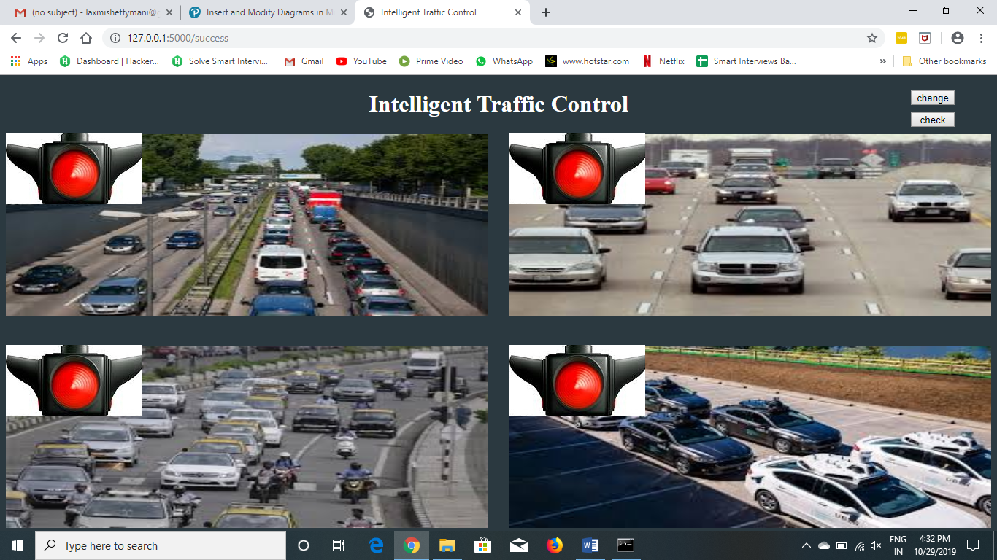

Fig 6.1 Starting webpage

As shown in Fig 6.1 will be loaded when you start the web page ,it has four image instances of the vehicles at four different sides at traffic signal junction.

It has two buttons on the top right, change an check. If you click change the webpage is loaded with the other 4 image instances of the vehicles and if you click check it will check the number of vehicles in each image instance and show the green signal to the image which has the highest number of vehicles.

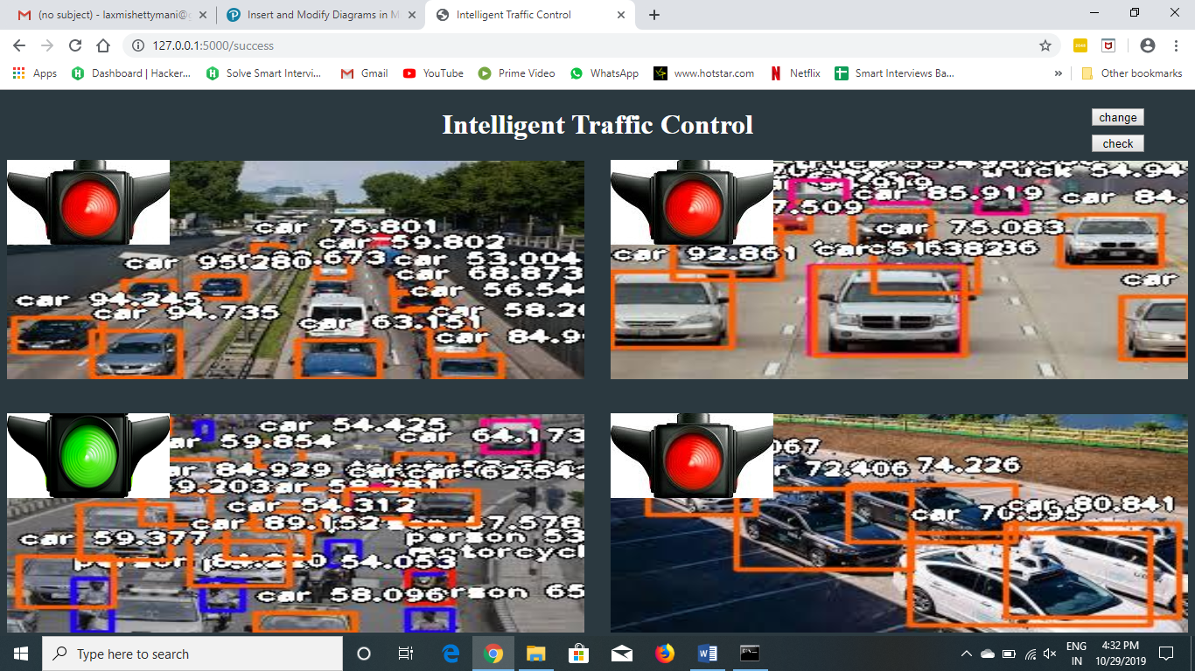

Fig 6.2 After clicking check button

As shown in Fig 6.2 after clicking the check button then you will get the above page. It will show the green signal to the road lane which has highest number of vehicles.

Also it will show the type of the vehicle recognized and the probability of the correctness of the vehicle recognized.

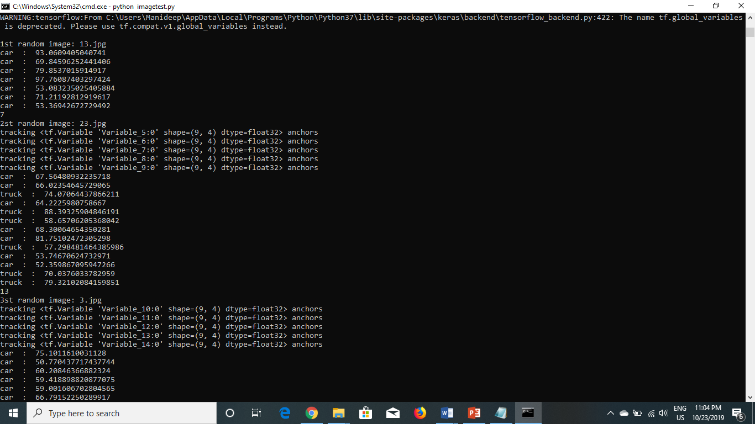

Fig 6.3 Loading the random images-1,2 and computing number of vehicles.

As shown in Fig-6.3 the loading of the first and second random images given in the input directory and the vehicles and persons recognized.It also shows the probability of the correctness of the vehicle recognized.

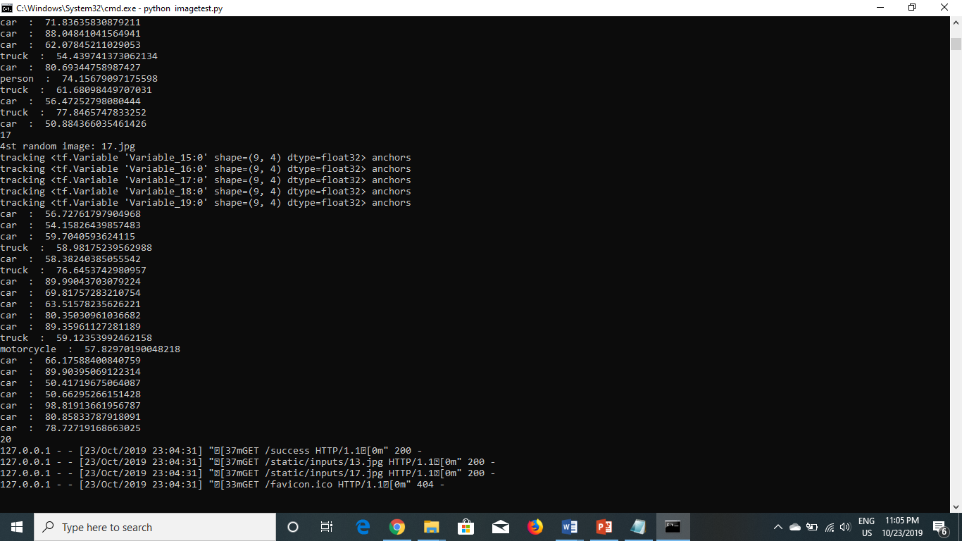

Fig 6.4 Loading the random images-3,4 and computing number of vehicles.

As shown in Fig-6.4 the loading of the third and fourth random images given in the input directory and the vehicles and persons recognized.It also shows the probability of the correctness of the vehicle recognized.

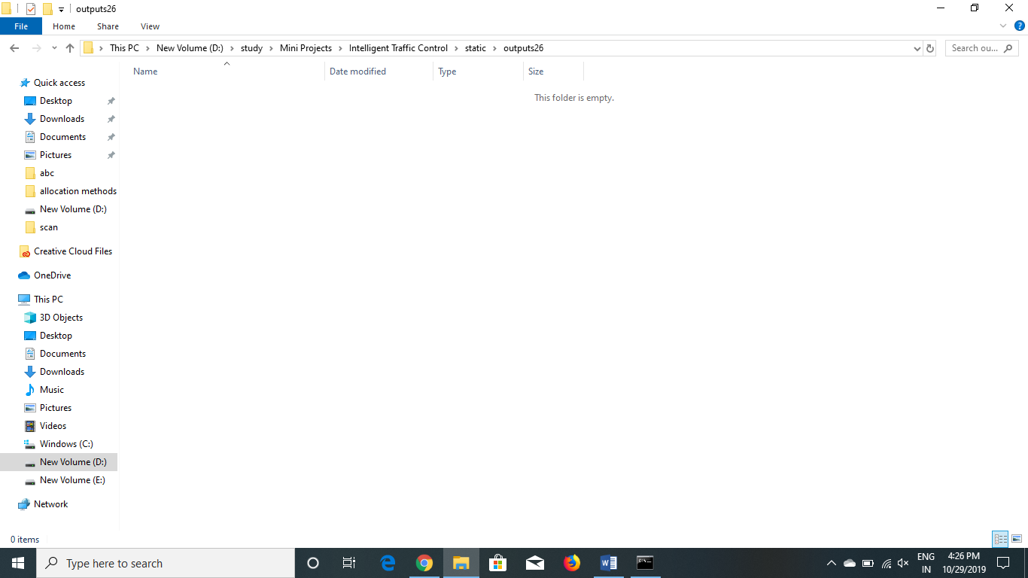

Fig-6.5 output directory before running of the code

As shown in Fig-6.5 the directory of the output images before the execution of the program .It is empty as there are no images loaded and computed in the server.

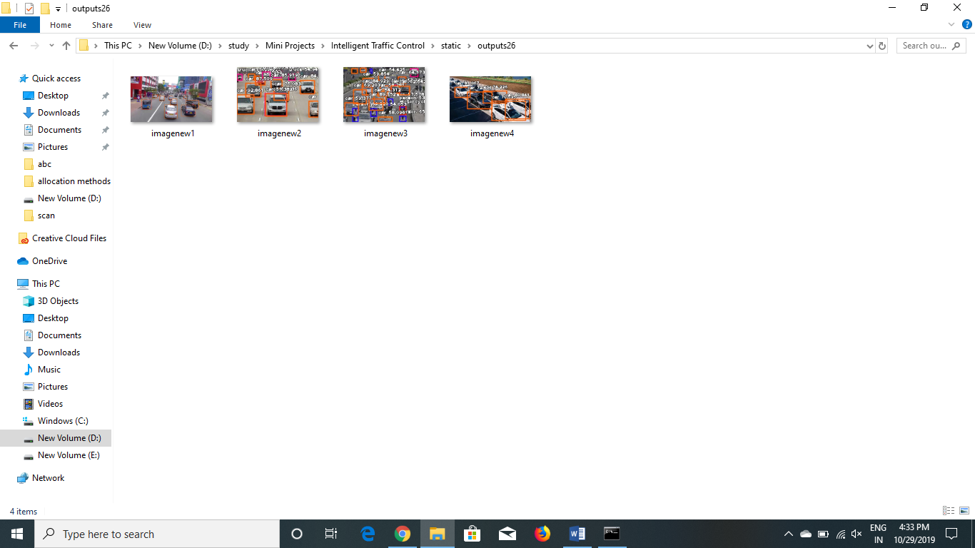

Fig-6.6 output directory after running the code, images are saved in the directory

As shown in Fig-6.6 the directory of the output images after the execution of the program .The four images are loaded and computed, the final images after recognized are saved in this folder.

**7. CONCLUSION AND FUTURE SCOPE**

The change of state using image processing method is successful in solving the issue of fixed timing of controller in controlling traffic and consequently will minimize the traffic congestion on the roads

Instead of images we can give directly the videos through cameras at traffic signal and compute the number of vehicles and show the signal accordingly.

The image instances given to the system is not dynamic. We can give the images of the instances dynamically using CC-cameras at four sides of the traffic junction.

One of the major problems faced by heavy traffic is by Ambulances. As we all know that Ambulances are the most important medical means of transport in any country as they carry patients to the nearby hospitals. But due to heavy traffic, one can often see the Ambulances stuck in traffic for long durations thus causing danger to patient’s life. So, our project extension is to solve this problem of Ambulances.

The image instances given to the system is not dynamic. We can give the images of the instances dynamically using CC-cameras.

**BIBLIOGRAPHY**

1. <https://www.w3schools.com/js/>
2. <https://www.geeksforgeeks.org/javascript-tutorial/>
3. <https://developer.mozilla.org/en-US/docs/Learn/HTML>
4. <https://www.google.co.in>
5. <http://flask.palletsprojects.com/en/1.1.x/>
6. <https://imageai.readthedocs.io/en/latest/>
7. <https://console.developers.google.com/>
8. <https://www.w3schools.com/>
9. <https://www.tutorialspoint.com/>